# User Interface Manual For ‘Look-up’

Designed and documented by Li Yunfan

## Loading Program

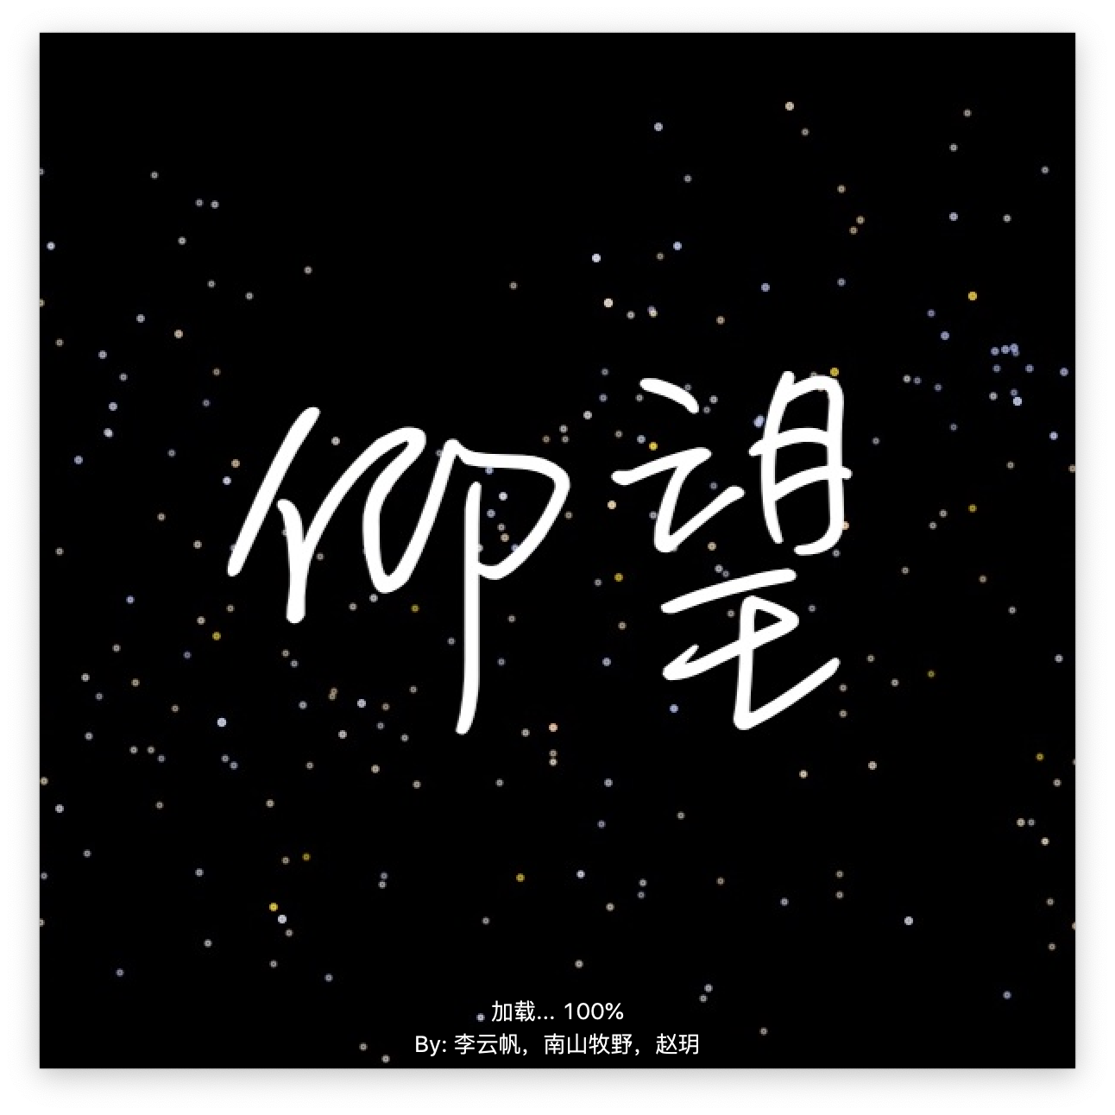

## Main Window

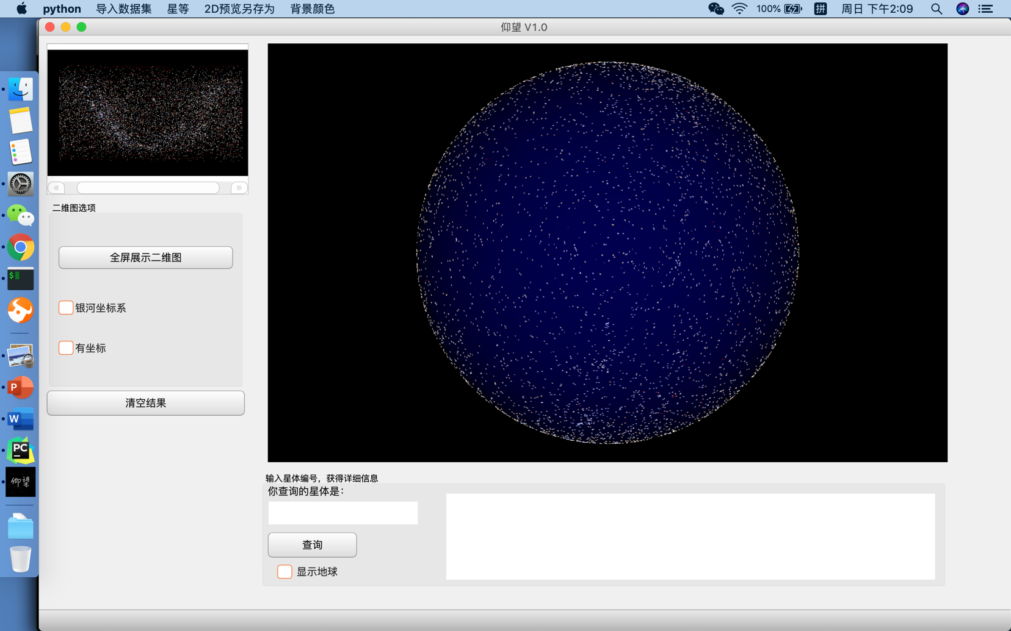

## Navigation Bar

## Change background color

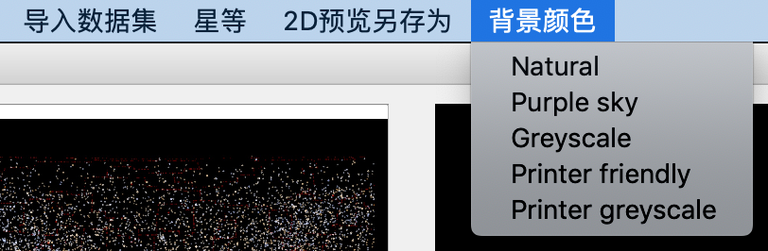

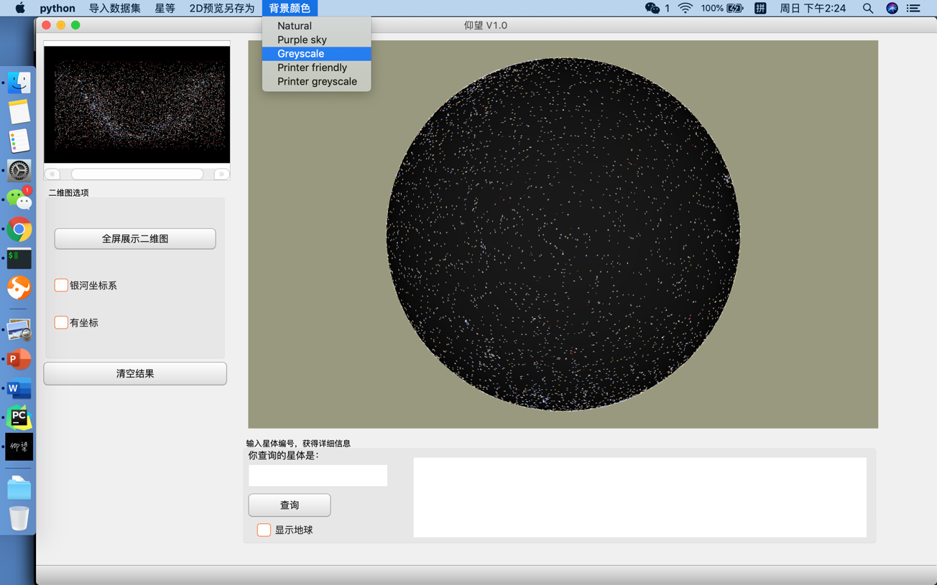

## Save as picture

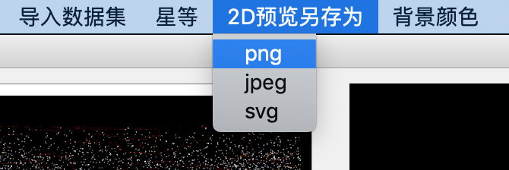

(Not yet implemented)

## Change star standard

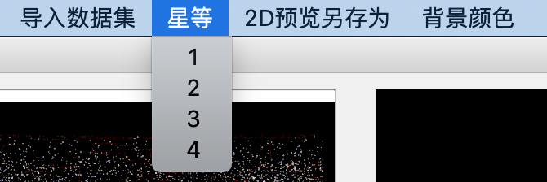

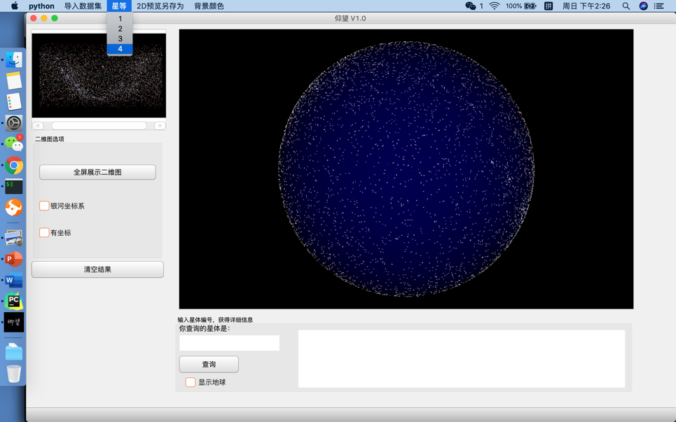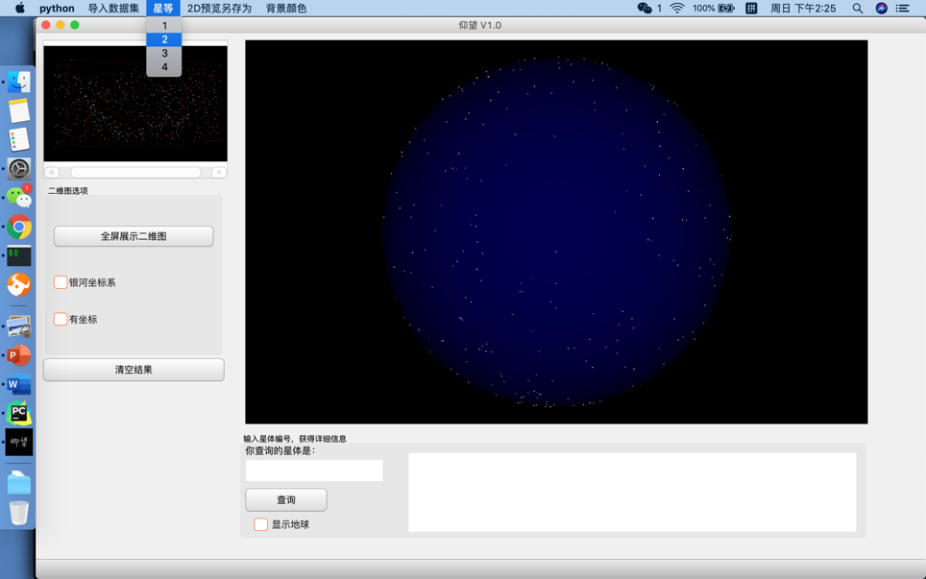

## Change dataset



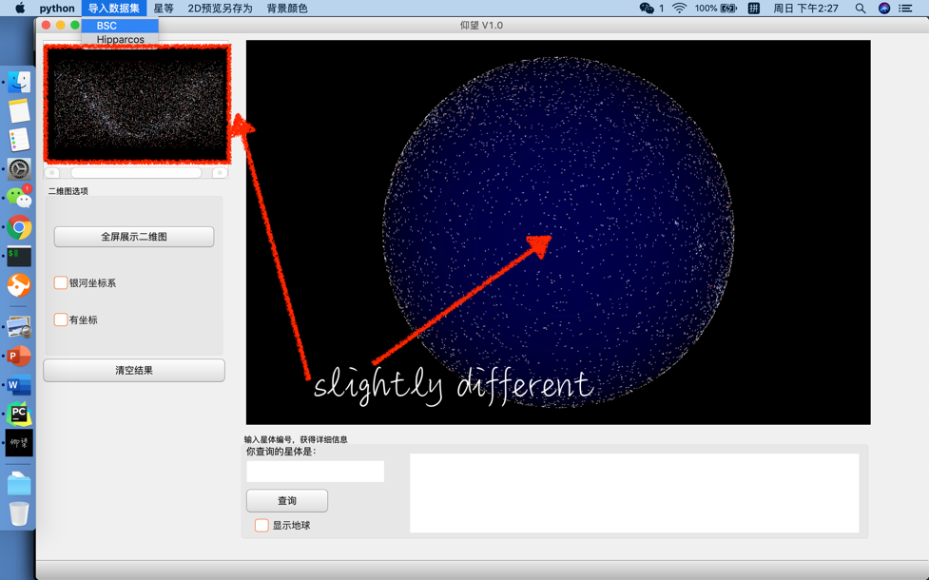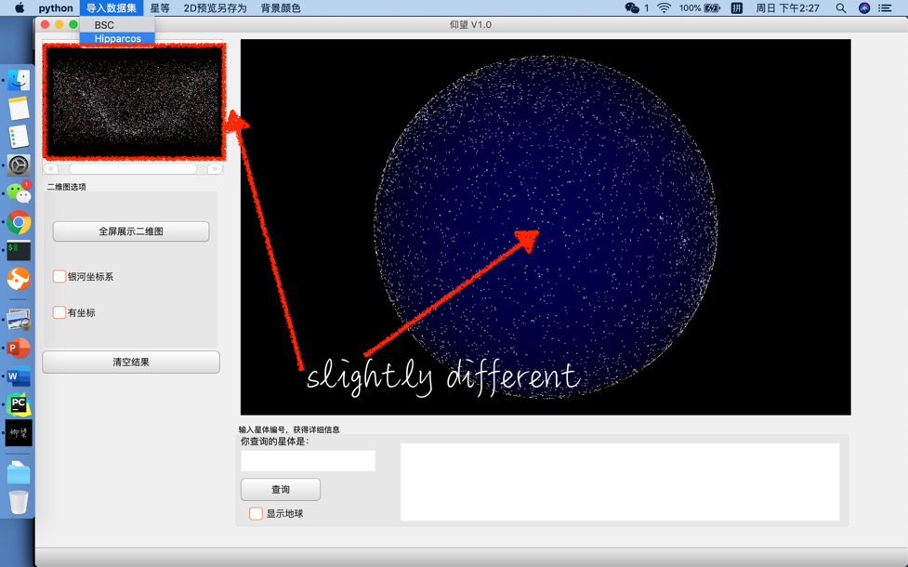

## With/without showing Earth

## Adding axis or changing to Galactic coordinates

## Search by star index

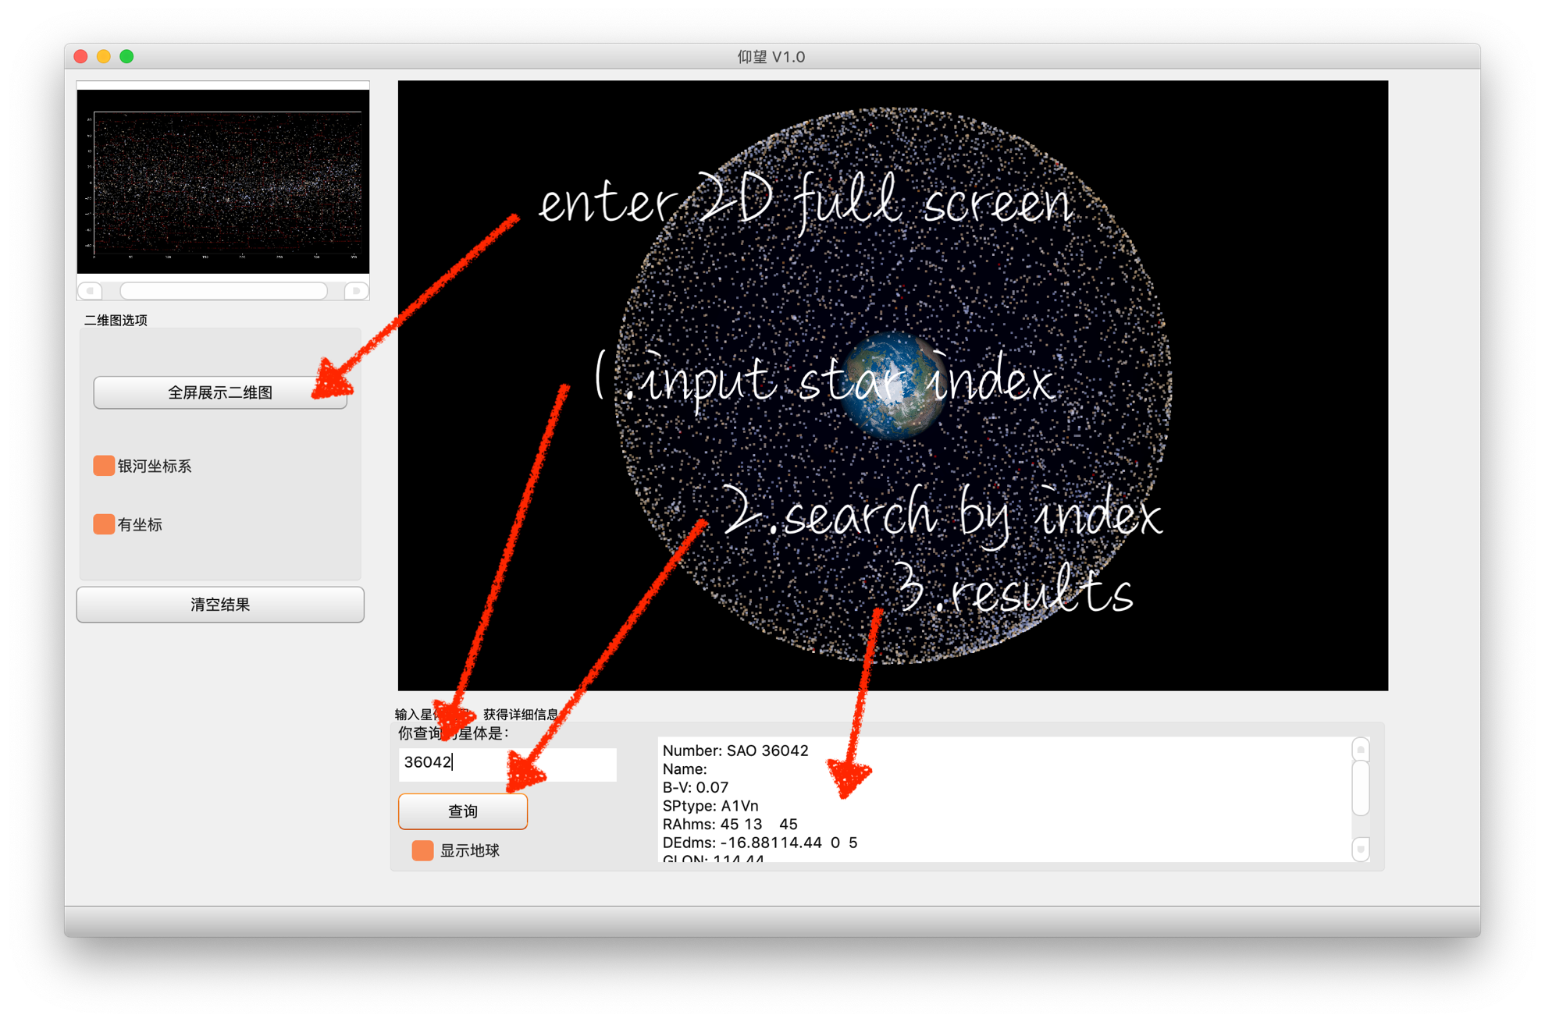Enter 2D-Full Screen preview

## Zoom in/out

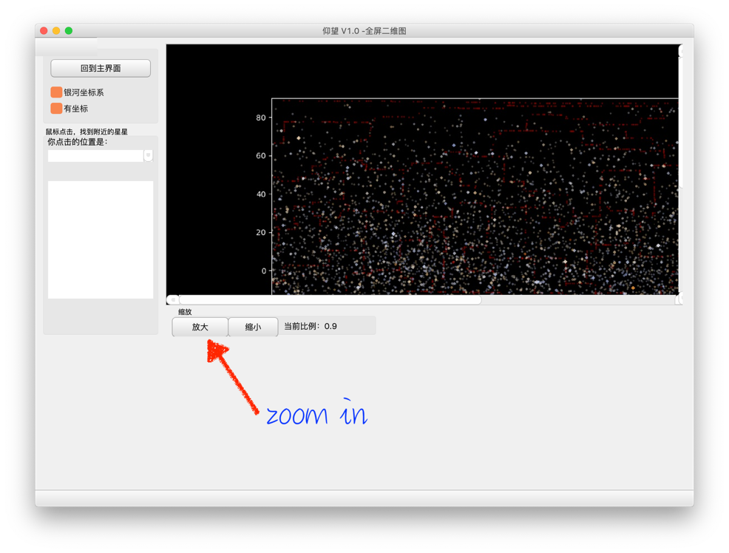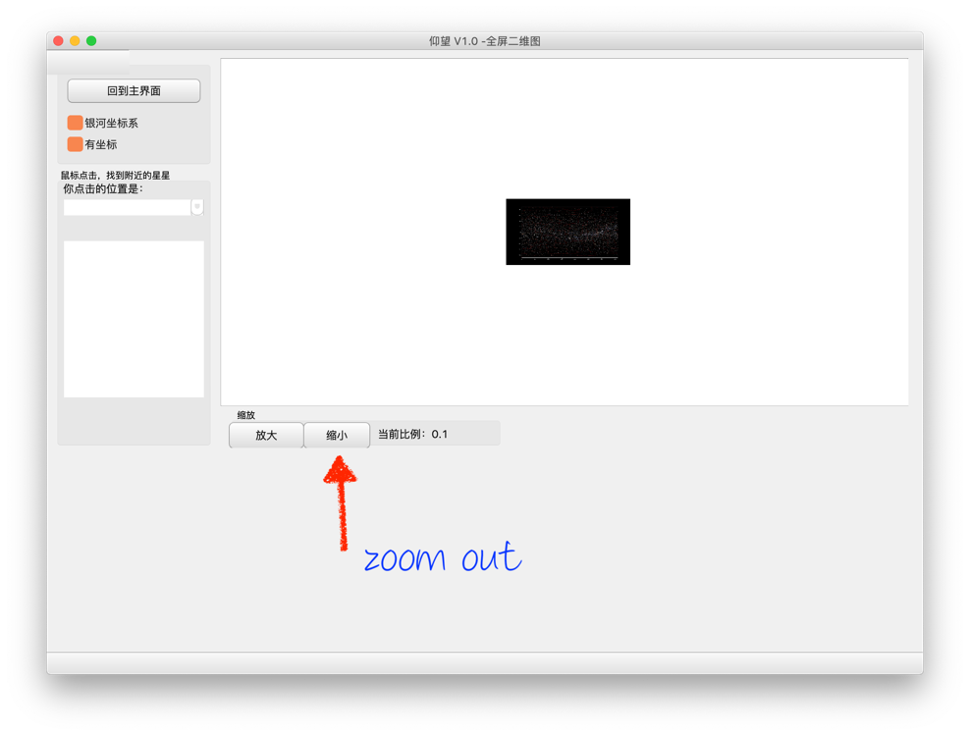

## Search by clicking on stars

